## **ABOUT KOBRA 6.5: KRAL KOBRA**

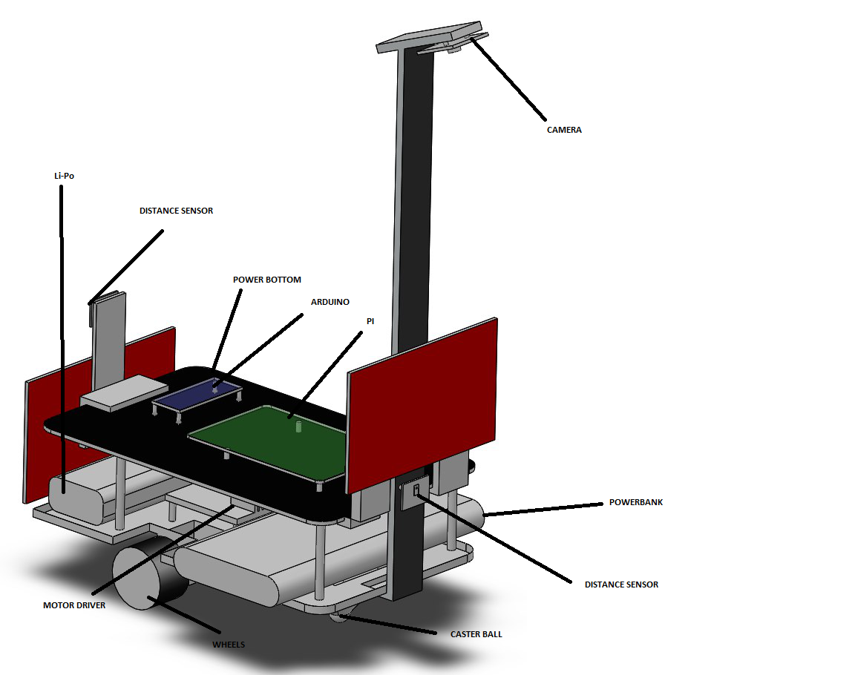

*Figure 1: Kobra 6.5 information*

**WARNING: Do not allow children to dismantle the KOBRA 6.5!**

**WARNING: Do not overcharge the KOBRA 6.5!**

## BOX INCLUDES

1x Kobra 6.5

1x Race Lane

1x USB Cable

1x Flash stick

1x Micro USB Cable

**NOTE:** A external HDMI capable Monitor, 3 Cell Li-Po battery charger and Quick Charge 3.0 capable plug-in charger should be bought separately to use KOBRA 6.5 safely.

## USAGE PROCEDURE:

Before race:

1. Check battery levels (1xLi-Po and 1xLi-Ion)
2. Connect the Micro USB cable of Powerbank to Raspberry Pi with monitor
3. Run delivered software to connect the opponent
4. Set the lane up
5. Place two KOBRA 6.5 on the lane
6. Check connection according to LEDs
7. Push the power button to start the race

## **CONNECTION**

By using provided software, you can connect two KOBRA 6.5. Contact DUAYENLER ltd. Şti. if you face any undesired problem with the software.

## **CHARGING OF KOBRA 6.5**

KOBRA 6.5 has two power supply into its chassis, so two of them should be charged correctly.

Li-Po battery should charge up to 12.6 V, overcharging is DANGEROUS.

**NOTE:** Li-Po charger which can avoid from overcharge is strongly suggest using.

Li-Ion battery could charge up to 100%.

# **Warranty Issues**

Following conditions will cause your KOBRA 6.5 to lose its warranty.

* Do not use KOBRA 6.5 in any environment with water.
* Do not throw KOBRA 6.5 height higher than 10 cm.
* Do not apply any kind of force to KOBRA 6.5 to check its strength.
* Do not use KOBRA 6.5 at temperature higher than 40 Celsius.
* Do not use damage batteries